

learn, laugh, live lilivelive llllivelive

Incorporatedded

S

**Newsletter – February 2025**

http://www.u3atawa.org.nz/

**2025 Annual General** **Meeting**

The New Year has kicked off with the Annual General Meeting on the 13th of January attended by 73 members – a very high turnout. It has been described as a warm, friendly and positive gathering.

The Committee members elected for the coming year were Marian Hobbs Chairperson, Judith Havill – Secretary, Marie Prescott -Treasurer, Tim Davin – Publicity, Barbara Woods - Course Co-ordinator, Pat Hammond – Committee, and Alison Bayly - Membership Secretary.

It was also decided that Subscriptions for 2026 will be $15 per person and the discounted rate for couples will no longer be available. Subscriptions are due from 1 December each year i.e. the financial year goes from 1 Dec 2024 until 30 November 2025. So, if you haven’t paid yet payment can be made by Internet Banking to the Tawa U3A BNZ account 02-0552-0198393-00 or paid directly at the NZ Post Shop in the Main Road.

**The February Committee Meeting**

At the Committee Meeting on the 3rd of February, it was reported that there are 218 members including 10 new members. This is excellent and the sign of a healthy Club.

We all forget to pay our Subscriptions at various times so Co-ordinators need to compare the list of the people who have registered (you will have recently been sent a list by Digby) with those who actually attend. It was suggested at the Committee that a gentle reminder by Co-ordinators to attendees to pay their Subscriptions would be a good idea.

**New Courses and Lectures for 2025**

There are some very interesting new courses arranged for 2025, and in particular you will see that Dave Smith is making a major and creditable contribution to this coming year’s programme.

**Investments**

This is an educational session by Jarden’s who will share their up-to-date advice on the many forms of accessible investments. There is only the one session on Wednesday the 19th of March at 10:00 am at the Tawa Union Church Lounge. The Co-ordinator is Dave Smith email - dogsnake33@gmail.com.

**Presidency of President Truman**

Across three Sessions the startling, pressured post war Truman years will be examined. At this point in his career, he had no high-level experience whatsoever. These will be held on Monday the 3rd of March, on the 17th of March, and on the 31st of March at 10:00 am at the Tawa Union Church Lounge. The Co-ordinator is Dave Smith email - dogsnake33@gmail.com.

**Piano Plus**

This will consist of a house concert of Chamber Music. Jancis and Chris will be joined by friends Barbara (violin) and Jane (cello) to play Piano Trios and other chamber music. It will be at a Member’s home on Thursday the 10th April. The venue and time will be advised. The Co-ordinator is Jancis Potter – email jancispotter@gmail.com.

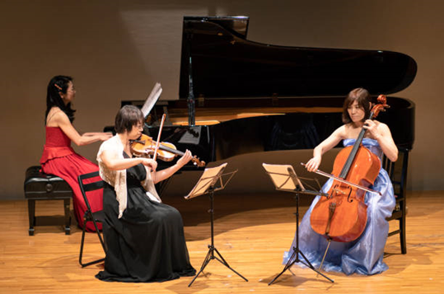

**Play Reading**

Come and read a part in a variety of plays – we share the roles throughout the plays, so we all have a turn reading! Maximum of eight people. This starts on the 26th of February 2025 at 11:00am and thereafter on the 4th Wednesday of the month at the Tawa Union Church. The Co-ordinator is Susan Bultitude, email - [susanjbultitude@gmail.com](mailto:susanjbultitude@gmail.com)

**Films on DVD**

This will involve watching and discussing a wide range of films - old and new. This will be limited to 6 people plus the co-ordinator. It starts on the 11th of February at 2 pm and then fortnightly. The Co-ordinator is Dave Smith email - [dogsnake33@gmail.com](mailto:dogsnake33@gmail.com).

**What I am Reading**

This is a presentation by members on the book they are currently reading. This will be held on the first Thursday of the month, beginning on the 6th of March. This is limited to 7 people. The venue is to be advised. The Co-ordinator is Dave Smith email - [dogsnake33@gmail.com](mailto:dogsnake33@gmail.com).

**English Civil Wars**

This is a fascinating story that ended with the Stuart monarchy being restored after just a few years. The events of that turbulent period contain many of the elements that eventually led to monumental changes for Britain and the world. This starts on Monday the 5th of May at 10 am, and there will be two further sessions fortnightly from May the 5th. The venue is the Tawa Union Church lounge. The Co-ordinator is Dave Smith email - dogsnake33@gmail.com.

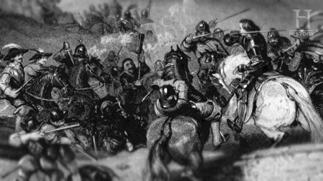

**Possible Outing with Porirua U3A**

 Porirua U3A are considering a possible visit to the Maraeroa Marae in Waitangirua.

The marae is an important part of the Porirua East Community, and the President, Gary Cherrington, would be very happy to host a group and tell us about its history. It would be interesting to understand the significance and symbolism of the Marae design and buildings.

Bill Gebbie is seeking interest from those who would like to join a group to visit the Marae. If there are sufficient numbers, he would work out a date and time. Could you please let Bill know, by Sunday the 14th of February, either by phone (0276770180), or email billnmary@xtra.co.nz if you would like to join the group.

Finally, don’t forget to regularly check the U3A Website for the latest news and updates at [www.u3atawa.org.nz](http://www.u3atawa.org.nz)

Tim Davin

Publicity - Tawa U3A Committee